|  |
| --- |
| **Consulting** |
| WMS Bartender Installation |
|  |

 



Content

Installation Guide 3

1.1 Files needed 3

1.2 BarTender software installation. 3

1.3 BarTender configuration 5

1.4 BullZip Installation: 5

# Installation Guide

## Files needed

* Copy on WMS server the file WMS.rar and uncompress.
* Copy PrinterServer folder under path C:\Argentis\bartender. Full path must be: C:\Argentis\bartender\PrinterServer

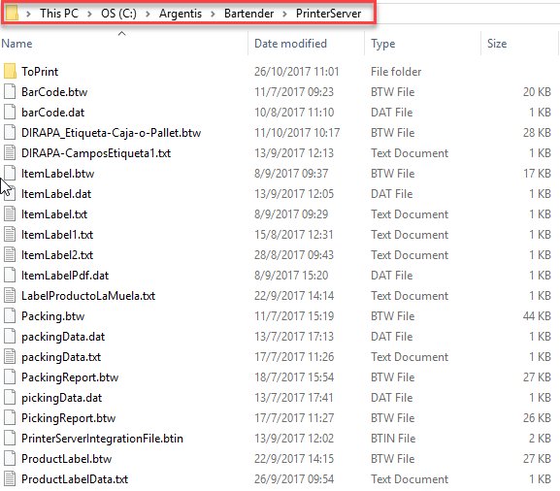

## BarTender software installation.

* Run BT2016_R4_3126_Full_x64.exe (Previously uncompressed from WMS.rar).
* Choose English and click on “install” (In case you already have license, choose “Enterprise” installation).
* Choose “Full install” and check “Include all of the .NET SDKs”

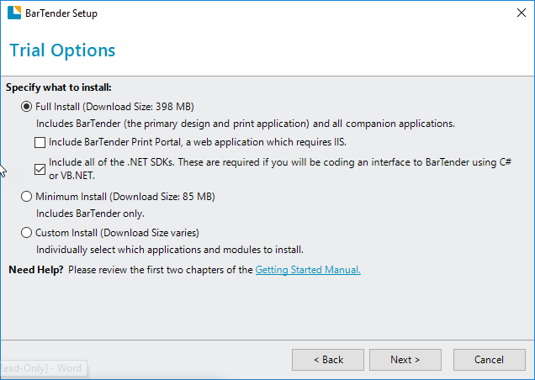

* Once finished, please uncheck all the options.

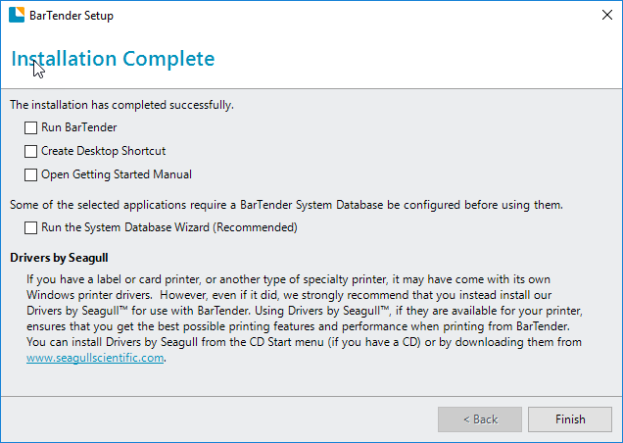

## BarTender configuration

* Run PrinterServerIntegrationFile.btin which is located on C:\Argentis\Bartender\PrinterServer folder.
* Click on “Deploy Integration”. Choose a name and click on Accept.

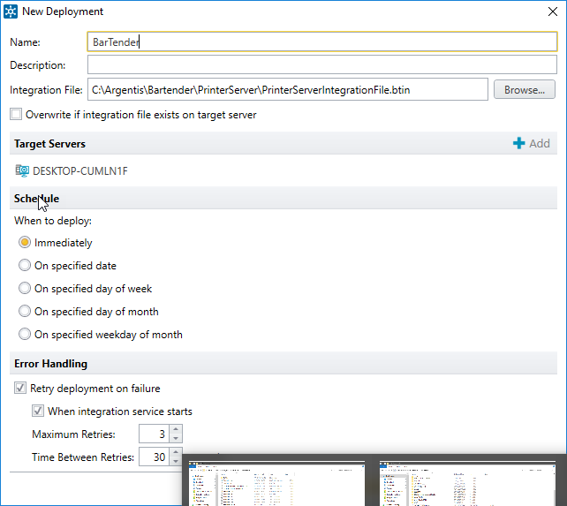

## BullZip Installation:

* Run Setup_BullzipPDFPrinter_11_4_0_2674_PRO_EXP.exe and perform the installation.
* Once the installation is finished, open BullZip PDF printer options.
* 
* On General tab, file name use: C:\Argentis\bartender\PrinterServer\ToPrint\PDF\<smarttitle>.pdf and uncheck the following options:

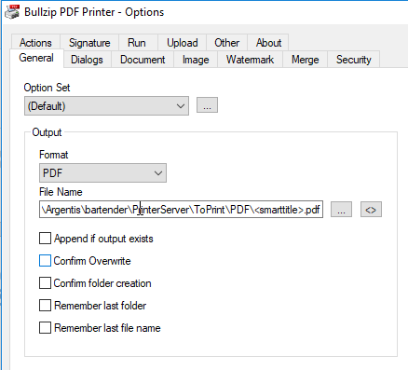

* On “Dialog” tab, select the following options:

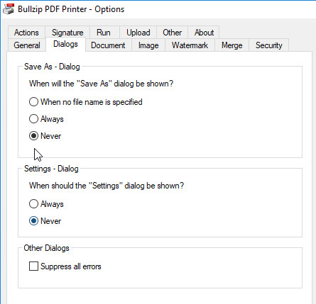

* Go to “Action” tab and select the following options:

